I.Matching

A.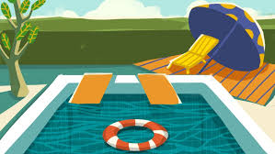 B. 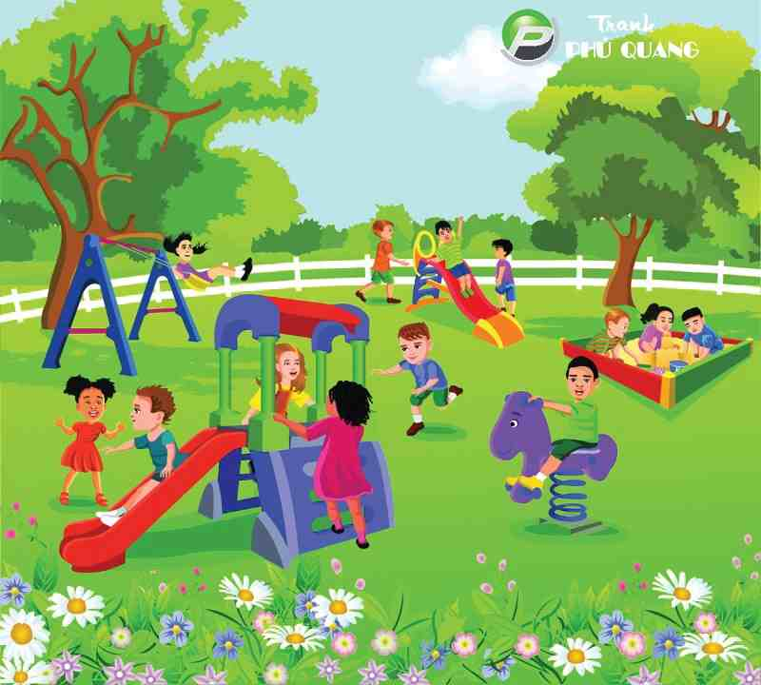\

C.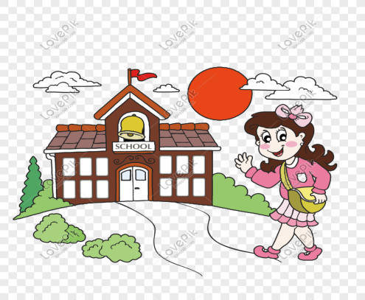 D.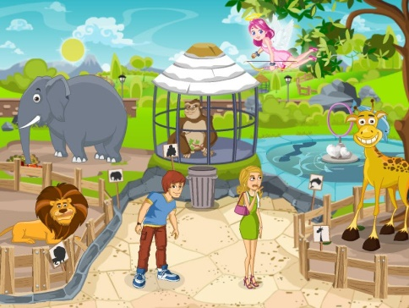

E. F.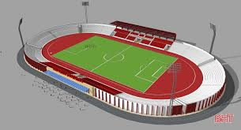

1.pool 2.park 3.mall

4.stadium 5.school 6.zoo

1….. 2….. 3….. 4….. 5….. 6…...

II.Write.

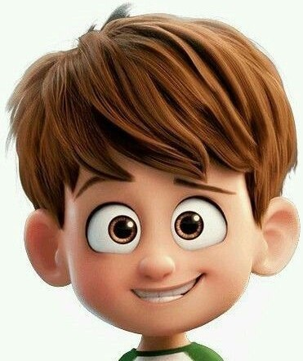

h………..

e………..

n……..

t………..

e…….

m………..



a…….

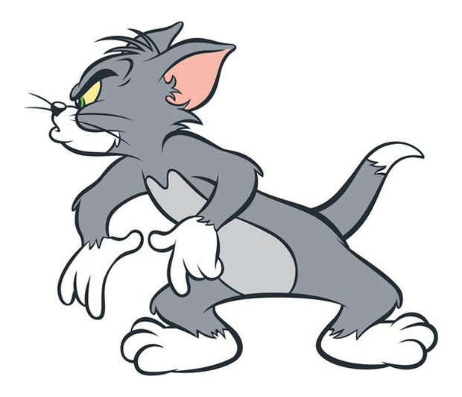

l………..

f……..

h………..

t………..

f………..

III.Circle.

1. 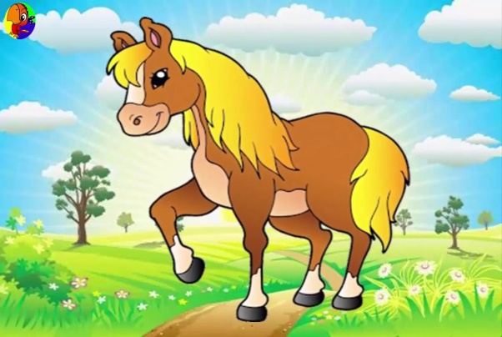 2. 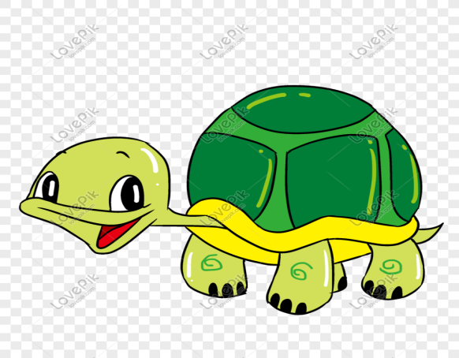

A.horse A.rabbit

B.bird B.turtle

C.dog C.cat

D.cat D.horse

1. 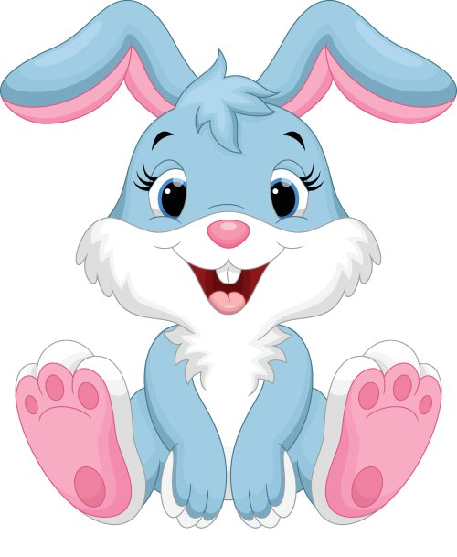
2. Snake
3. Tiger
4. Iguana
5. monkey